**WEEK 7 – SUPPLIER DATABASE**

**(Tuesday, 20-12-2022)**

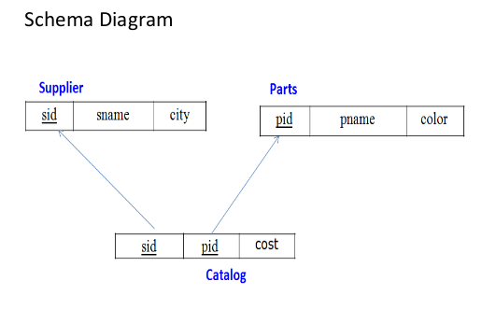

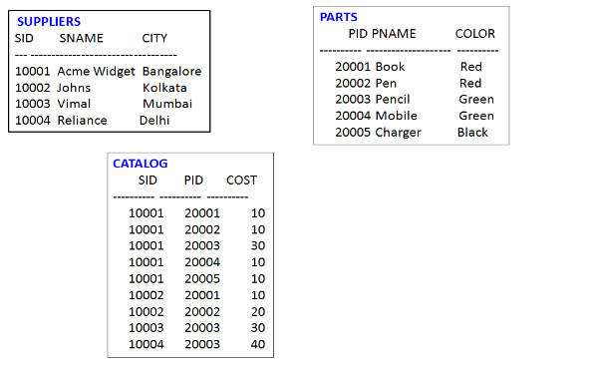

**TO DO:**

1. **Using Scheme diagram, Create tables by properly specifying the primary keys and the foreign keys.**

**(CREATION)**

create database dhiksha_supplier;

use dhiksha_supplier;

create table dhiksha_supplier.Supplier(

sid int,

sname varchar(15),

city varchar(10),

PRIMARY KEY(sid)

);

create table dhiksha_supplier.Parts(

pid int,

pname varchar(10),

color varchar(5),

PRIMARY KEY(pid)

);

create table dhiksha_supplier.Catalog(

sid int,

pid int,

cost int,

PRIMARY KEY(sid, pid),

FOREIGN KEY(sid) REFERENCES Supplier(sid),

FOREIGN KEY(pid) REFERENCES Parts(pid)

);

1. **Insert appropriate records in each table.**

**(INSERTION)**

insert into Supplier values(10001,"Acme Widget", "Bangalore");

insert into Supplier values(10002,"Johns", "Kolkata");

insert into Supplier values(10003,"Vimal", "Mumbai");

insert into Supplier values(10004,"Reliance", "Delhi");

insert into Parts values(20001,"Book", "Red");

insert into Parts values(20002,"Pen", "Red");

insert into Parts values(20003,"Pencil", "Green");

insert into Parts values(20004,"Mobile", "Green");

insert into Parts values(20005,"Charger", "Black");

insert into Catalog values(10001,20001, 10);

insert into Catalog values(10001,20002, 10);

insert into Catalog values(10001,20003, 30);

insert into Catalog values(10001,20004, 10);

insert into Catalog values(10001,20005, 10);

insert into Catalog values(10002,20001, 10);

insert into Catalog values(10002,20002, 20);

insert into Catalog values(10003,20003, 30);

insert into Catalog values(10004,20003, 40);

**(SELECTION)**

select * from Supplier;

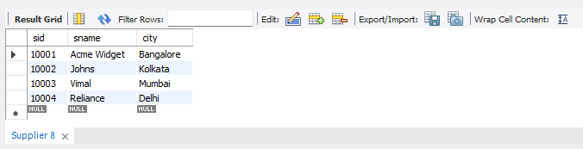

select * from Parts;

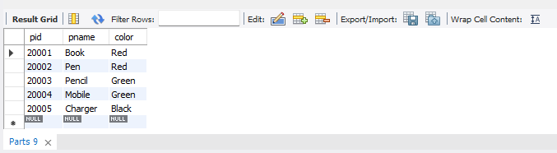

select * from Catalog;

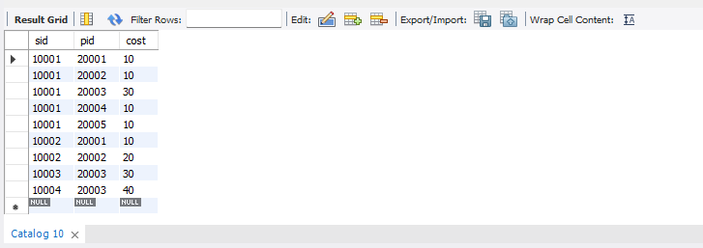

1. **Find the pnames of parts for which there is some supplier.**

select distinct p.pname

from Parts p, Catalog c

where p.pid = c.pid;

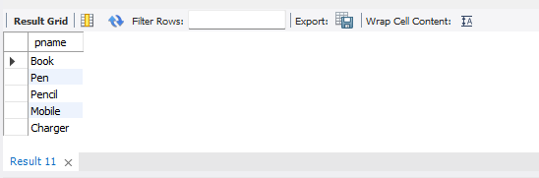

1. **Find the snames of suppliers who supply every part.**

select distinct s.sname

from Catalog C, Supplier s WHERE C.sid=s.sid and NOT EXISTS (select P.pid FROM Parts P

where NOT EXISTS (select C1.sid from Catalog C1

where C1.sid = C.sid and C1.pid = P.pid));

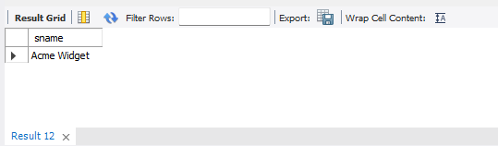

1. **Find the snames of suppliers who supply every red part.**

select distinct s.sname

from Catalog C, Supplier s where C.sid=s.sid and NOT EXISTS (select P.pid from Parts P

where P.color="Red" and NOT EXISTS (select C1.sid from Catalog C1

where C1.sid = C.sid and C1.pid = P.pid and P.color="Red"));

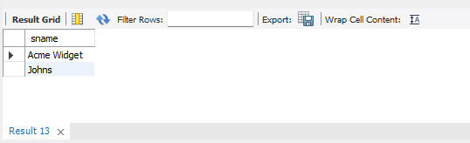

1. **Find the pnames of parts supplied by Acme Widget Suppliers and by no one else.**

select P.pname

from Parts P, Catalog C, Supplier S

where P.pid = C.pid and C.sid = S.sid and S.sname = "Acme Widget"

and NOT EXISTS (select * from Catalog C1, Supplier S1

where P.pid = C1.pid and C1.sid = S1.sid and

S1.sname != "Acme Widget");

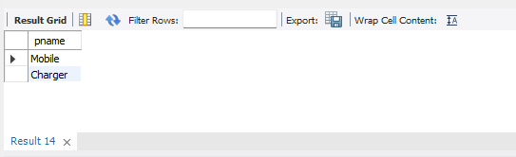

1. **Find the sids of suppliers who charge more for some part than the average cost of that part (averaged over all the suppliers who supply that part).**

select distinct C.sid from Catalog C

where C.cost > (select AVG(C1.cost)

from Catalog C1 where C1.pid = C.pid);

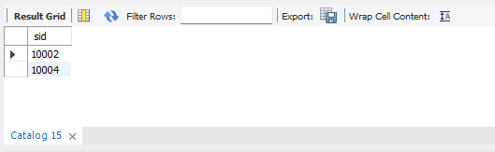

1. **For each part, find the sname of the supplier who charges the most for that part.**

select P.pid, S.sname

from Parts P, Supplier S, Catalog C

where C.pid = P.pid and

C.sid = S.sid and

C.cost = (select max(C1.cost)

from Catalog C1

where C1.pid = P.pid);

